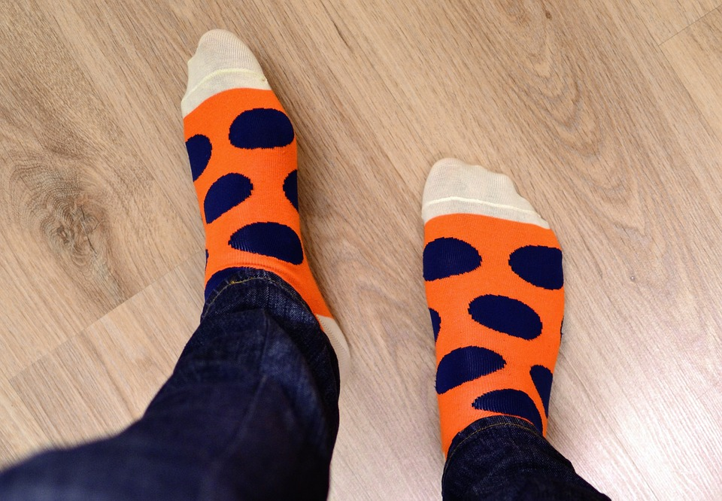

Name: __________________

If your SOCKS could talk, they would tell me:
________________________________________________________________________________________________

Name: __________________

If your SOCKS could talk, they would tell me:
________________________________________________________________________________________________

